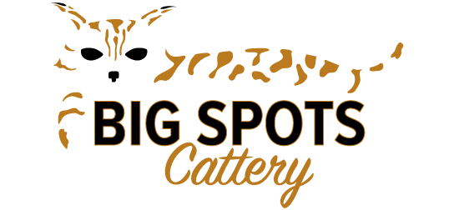

Purchase Agreement

I__________________________ wish to purchase a kitten from Big Spots Cattery. I understand that this is a pet/companion animal only and that I may NOT breed my animal. I agree to spay or neuter between the ages of 5 and 6 months to ensure my kitten does not spray. I understand that both male and female desert lynx cats will spray if not altered between 5 and 6 months of age. In addition, I agree not to declaw my cat or allow my cat to go outdoors alone. I also agree not to allow a vet to use ketamine on my cat as anesthesia, as it is dangerous for the desert lynx breed and may cause seizures and other health issues.

Big Spots Cattery agrees to ensure the kitten is healthy and has had its first sets of shots prior to leaving the premises of Big Spots Cattery. A veterinarian’s health inspection is available upon request. After this point, I understand that I am fully responsible for the health of my cat.

I have enclosed a non-refundable deposit of $____________ to go towards the purchase price of $_____________. I understand that full payment is due on or before pick-up in the form of cash or money order. I understand that this price is for the animal only and any other charges, such as boarding and shipping (we use Meowhaus, http://meowhaus.biz/), are my responsibility.

I will
Pick up my cat in person from Big Spots Cattery

Use Meowhaus to ship my cat

Buyer’s signature:_____________________________________________

Buyer’s address_______________________________________________

City_____________________________State_________ Zip____________

Phone number (_____)____________Email ________________________

